In the name of God

EE 432 Lab1 : Ground Reflection

Name: Mohammad Chahardori (Student ID: 11632753)
Partner: Richard Osorio
Due Date: 09/21/2020

Description:
Purpose of the Lab:
In this project we are supposed to learn the
- Measurement of the field strength
- The effect of the ground on radio propagation
- Application of the ground reflection models to represent the data
In this lab we should learn the field strength measurement techniques and the effect of ground reflection on transmission and using different propagation models and how to fit them to the data. We have used the online data provided based on previous measurement. However, based on the data provided to us we realized that a field transmitter transmitting at 915 megahertz was set up at the static point then using a field strength meter the received power was recorded every 10ft for 300 feet ( in fact data has been provided up to 291 feet instead of 300 feet) and the height of the transmitter and receiver were kept constant. The measurement setup is shown in Figure 1.
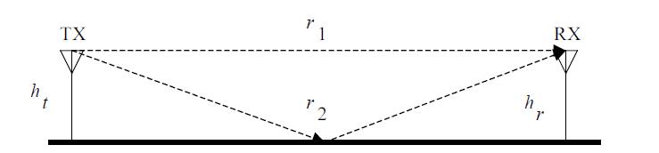
Figure 1: Setup for the experiment
In this figure, TX represents the transmitter and RX is the receiver.
$h_{t}$ = height of the transmitter, $h_{r}$ = height of the receiver.
The straight forward path is represented by $r_{1}$, and the reflected path from ground is represented by $r_{2}$.
Procedure:
In the provided measurement, we had
$h_{r}$ = 72 in = 1.828 m
$h_{t}=39 inch= 1m$
All the measured powers were in dBm scale. Using the provided data and Matlab software we have found the parameters of the three different models explained as approximations of the received power in EE432 course. The three approximation models for this purpose are:
- The free space model
- The break-point model
- The two-ray model

Here we briefly review of the models and procedure to find the best fit for these models.
- The Free Space Model:
For the free space model, received power is given by:
$P_{r}=P_{o}-20\log\left(\frac{r}{r_{o}}\right)$ (1)
Here $r_{o}$ is given by:
$r_{o}=\frac{2πh_{t}h_{r}}{λ}$ (2)
Where $λ$ is the wavelength.
Since frequency of the transmitter, $f=915 MHz$,
The wavelength is found to be: $λ=\frac{300}{915}m=0.327m$
$r_{o}=\frac{2π×1.828×1}{0.327}=34.71m$ (3)
The aim of this model is to find the value of $P_{o}$ which results is the minimum root mean
square (rms) error ($σ$), which is given by:
$σ= \sqrt{\frac{1}{N}\sum_{k=1}^{N}{{\left(P_{r,k}-P_{m,k}\right)}^{2}}}$ (4)
Where the $P_{r,k}$ is the measured received power and the $P_{m,k}$ is the received power calculated from the models. In this model since $r_{o}$ is determined from (2), the only parameter needed to be optimized and determined is $P_{o}$ . We swept the $P_{o}$ in (1) from 0 to -100dBm with 1dB step and calculated $σ$from (4). The $P_{o} providing the$ minimum value of $σ$ is the optimum $P_{o}$ .
- The Break-Point Model:
The break-point model uses $r_{o}$ as the break-point, where the model changes from one type of behavior to another. The model can be expressed as:
$P_{r}= \left\{\begin{aligned}P_{o}-20\log\left(\frac{r}{r_{o}}\right);when r<r_{o} \\ P_{o}-20\log\left(\frac{r}{r_{o}}\right);when r>r_{o}\end{aligned}\right.$ (5)
We used a similar approach to find the optimum value of Po which results in the rms error becomes minimum. Matlab code A.2 has been used for this modeling.
- The Two-Ray Model:
In this model, which can offer more accurate result for received power, the received power is given by:
$$P_{r}=P_{o}+20\log\left|\frac{r_{o}}{r_{1}}\right.+Γe^{-j\frac{2π}{λ}\left(r_{2}-r_{1}\right)}\left.\frac{r_{o}}{r_{2}}\right| \left(6\right)$$
$r_{1}= \sqrt{r^{2}+{\left(h_{t}-h_{r}\right)}^{2}}$; $r_{2}= \sqrt{r^{2}+{\left(h_{t}+h_{r}\right)}^{2}}$ (7)
In contrast to the other two models, in this model we have two parameters which are needed to be optimized. the reflection coefficient of ground ($Γ$), and the Po. To find the optimum value for these two parameters we have used two loops to sweep them. Each time we found the value of $P_{r}$ from (6) and calculated the rms error $σ$from (4) and based on the minimum $σ$ we determined the value of optimum Po and $Γ$, using a Malab code. Matlab code A.3 has been used for this modeling. In this code we manually changed the value of the reflection co-efficient from -1 to 0 with -0.1 steps since the pathway is not a perfect reflector. The value of $P_{o}$ is varied from 0 dBm to -100 dBm with -1 dB step.
Results and Analysis:
In this part of the lab report we will briefly discuss the results and Analysis regarding to each method of the field transmission modeling and achieved parameters based on the provided data.
- The Free Space Model Results:
Matlab code A.1 has been used for free space modeling in this lab. For the provided data we achieved the following $P_{o}$ and $σ$ as the optimum data fitting for free space model:
$$r_{o}=34.7 m$$
$P_{o}$= -59 dBm
and
$$σ= 9.68 dB$$
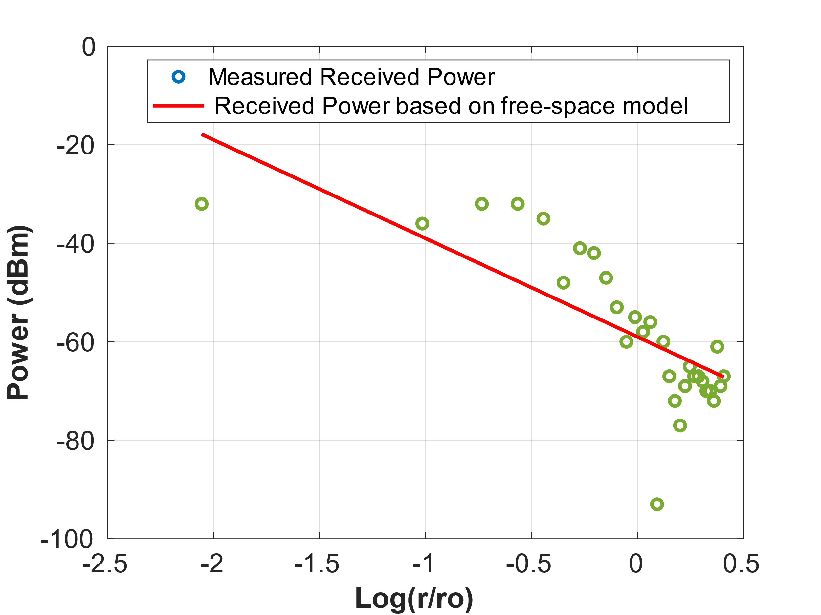
In free space model there is no need to calculate the $r_{o}$ from (4), however we used this $r_{o}$ to find optimum $P_{o}$ as an arbitrary value for $r_{o}$. In figure. 2, the measured data points and the linear graph for free space modeling have been shown for the optimum Po in a logarithmic scale for distance.
Figure 2: Measured Power and free space model

- The Break-Point Model Results:
Matlab code A.2 has been used for break point modeling in this lab. For the provided data we achieved the following $P_{o}$ and $σ$ as the optimum data fitting for break point model:
$$r_{o}=34.7 m$$
$P_{o}$= -56 dBm
and
$$σ= 9.108 dB$$
In figure. 3, the measured data points and the graph for break point modeling have been shown for the optimum Po in a logarithmic scale for distance.
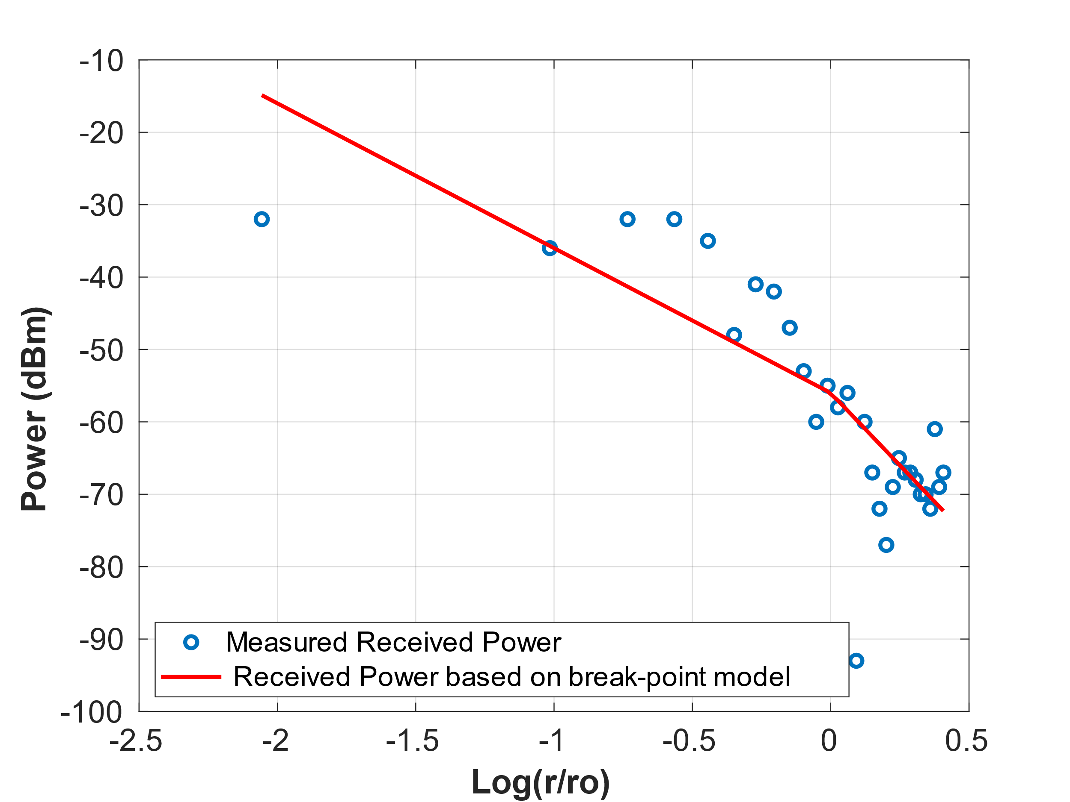
Figure 3: Measured Power and break point model

- The Two-Ray Model Results:
Matlab code A.3 has been used for free space modeling in this lab. As we explained before in this report, we need to optimize the value of Po and also the ground reflection coefficient $Γ$ at the same time to achieve the optimum model. Using a Loop in Matlab code for Po and manually sweeping the $Γ$, we tried to find the optimum values for Po and the $Γ$ . In table I the value $σ$ of for different Po and $Γ$ are seen.

Table 1: rms error ($σ)$ at different reflection co-efficient $Γ$ and $P_{o}$ values
 | $P_{o}$= -58 dBm | $P_{o}$= -59dBm | $P_{o}$=-60dBm
$$Γ= -0.7$$ | 9.7457 | 9.2407 | 9.6912
$$Γ= -0.6$$ | 9.6290 | 9.2175 | 9.5456
$$Γ= -0.5$$ | 9.5397 | 9.1908 | 9.4574
$$Γ= -0.4$$ | 9.3817 | 9.1710 | 9.3774
$$Γ= -0.3$$ | 9.2650 | 9.1658 | 9.2778
$$Γ= -0.2$$ | 9.3508 | 9.1758 | 9.3885

Based on the table, the following parameter achieved for the optimum fitting in 2-Ray model:
$$r_{o}=34.7 m$$
$P_{o}$= -59 dBm
$$Γ=-0.33$$
and
$$σ= 9.16 dB$$

In figure. 4, the measured data points and the graph for 2-Ray modeling have been shown for the optimum Po and $Γ$ in a logarithmic scale for distance.

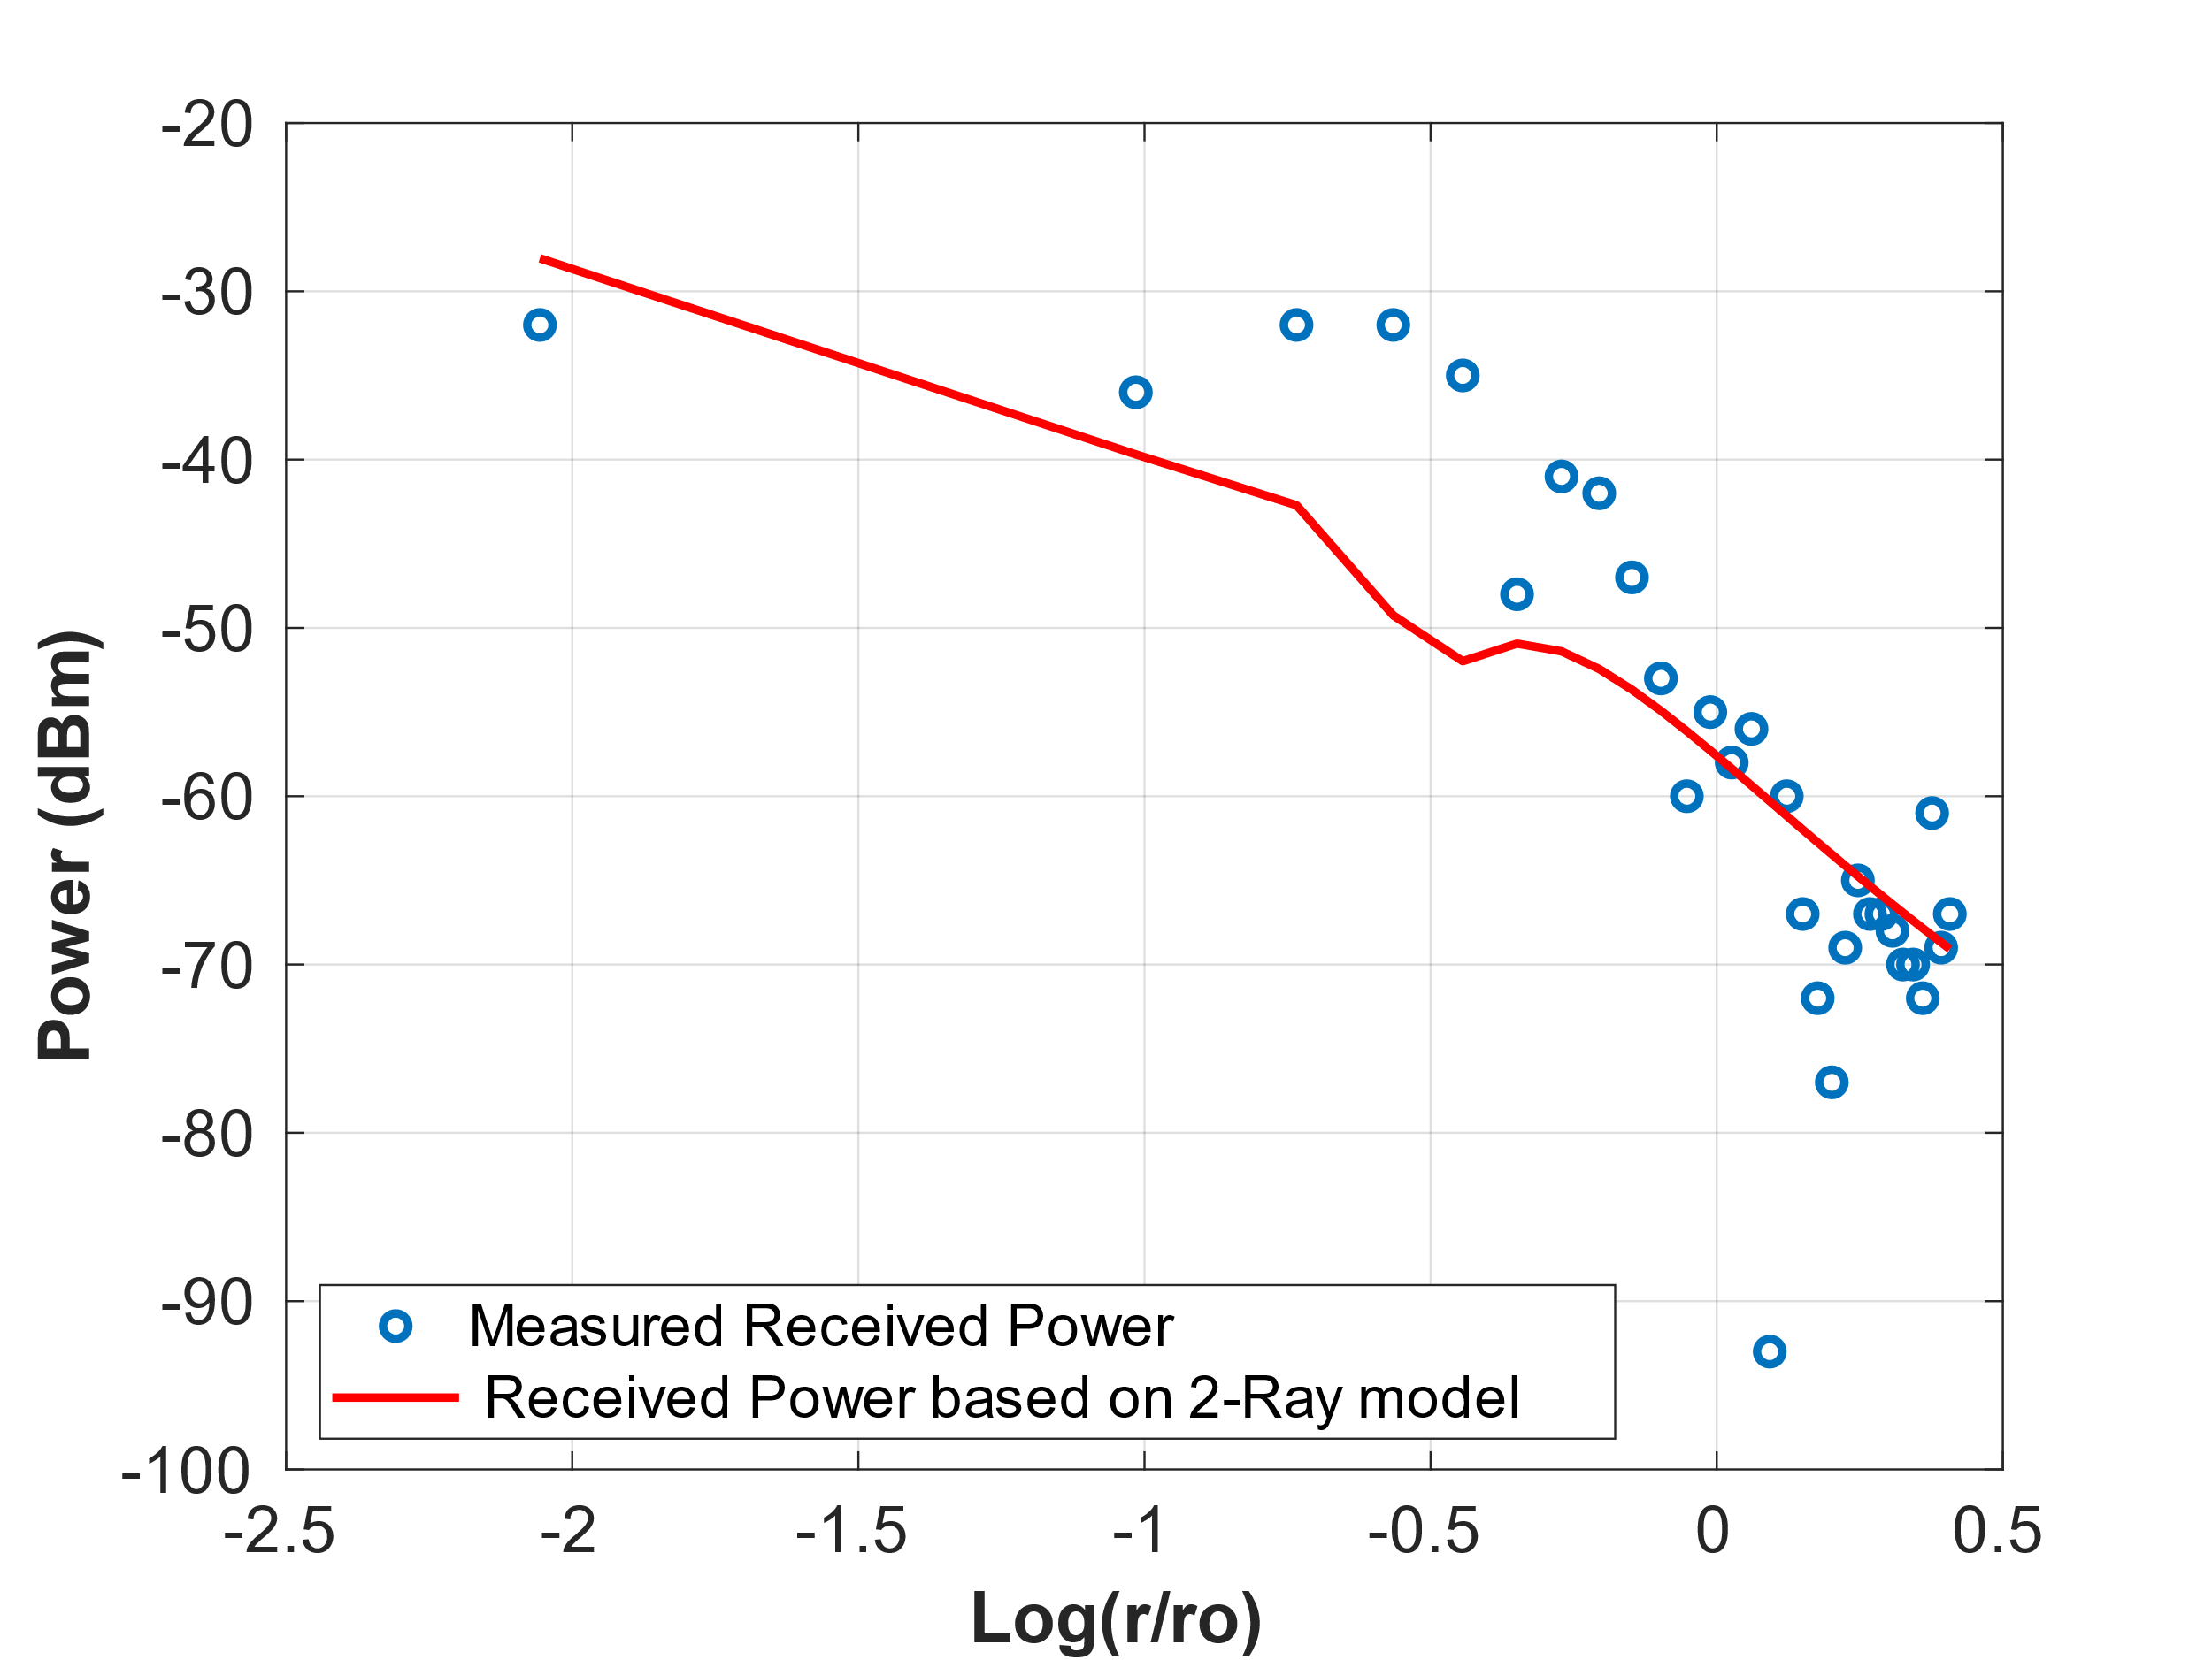
Figure 4: Measured Power and 2-Ray model

Conclusion and discussion:
Figure 5 shows the measured data points along with the “best fit” for all three models. As seen in Figure 5, some points in the graph are way off the models, specially at higher distances. Perhaps this is because of some other phenomenon that we have not considered in this lab such as multipath and fading or due to some measurement errors.
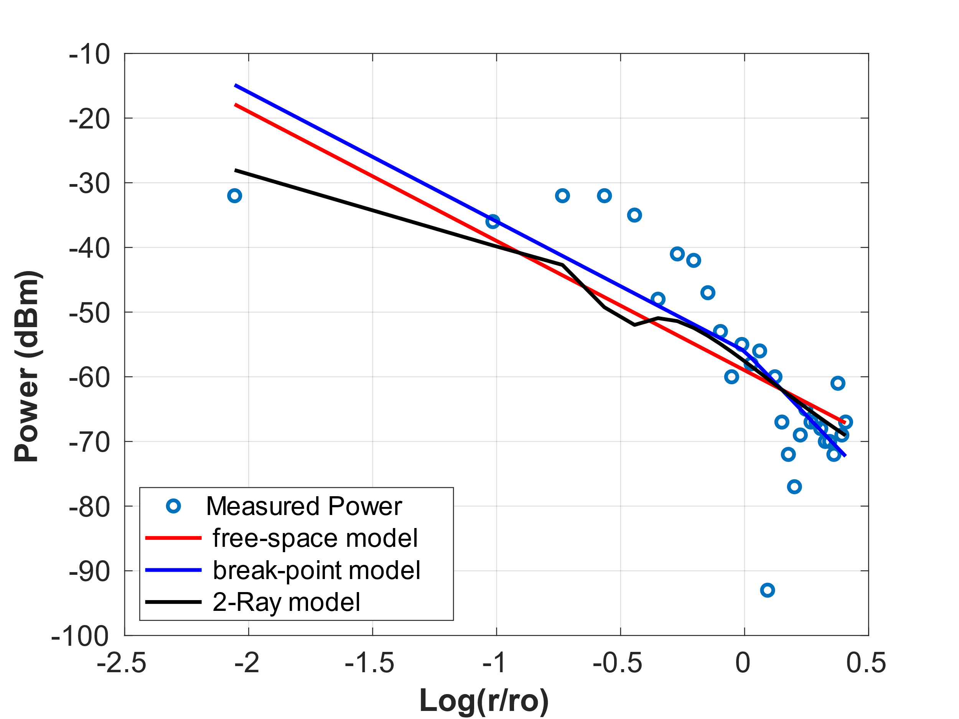
Figure 5: Measured Power and all approximation models

Also, as we have seen in the previous section, the best result is achieved from the breakpoint model in this experiment, while we expect to get better result in 2-Ray model. I think that is mostly because, the number of data points and measurement points in the short distances is not sufficient. Most of the provided points are measured at r > ro and due to the lack of enough measurements before the ro we don't see the effectiveness of 2-Ray model to provide good approximation for distances less than ro and distances more than ro at the same time. In fact, since the measured points are mostly after the breaking point so the breaking point model can model the received power a little better than 2-ray. Also, since we have some points with large difference from the expected values, the amount of variance in all 3 different models is larger than 9dB. I think if we measure these points again and get more accurate results the variance of the model would be much better and also if we increase the number of measured points especially for the distances before ro we can get lower rms error especially in 2-ray model.

Appendix A.1
Code for the free space model:
clc
%++++++++++++++++++++++++++++++++++++++++++++++++++++
% Initialization of Parameter
%++++++++++++++++++++++++++++++++++++++++++++++++++++
Frequency_MHz = 915;
lambda = 300/Frequency_MHz;

height_transmitter_inch = 39;
height_transmitter_meter = height_transmitter_inch * 0.0254;
height_receiver_inch = 6*12;
height_receiver_meter = height_receiver_inch * 0.0254;

r_0_distance = 2 * pi * height_receiver_meter * height_transmitter_meter / lambda

%++++++++++++++++++++++++++++++++++++++++++++++++++++++++++++++++++++++
% Input values and conversion of distances from other units to meter
%++++++++++++++++++++++++++++++++++++++++++++++++++++++++++++++++++++++

Pr_dBm = -1 * [ 32 36 32 32 35 48 41 42 47 53 60 55 58 56 93 60 67 72 77 69 65 67 67 68 70 70 72 61 69 67 ];
r_feet = 1:10:300;
r_meter = r_feet * 0.3048;
Rlog = log10(r_meter ./ r_0_distance);

N = length(Pr_dBm);

%++++++++++++++++++++++++++++++++++++++++++++++++++++++++++++++++++++++
% Calculating the Received Power using free-space modeling
%++++++++++++++++++++++++++++++++++++++++++++++++++++++++++++++++++++++

Po = -59
for i=1:N
Pr(i) = Po - 20 * log10(r_meter(i)/r_0_distance);
end
Pr_free_space = Pr;
sigma_square = sum((Pr_dBm - (Pr)).^2) /(N); % Determining the standard deviation
sigma_free_space = sqrt(sigma_square) % Determining the rms error

%++++++++++++++++++++++++++++++++++++++++++++++++++++++++++++++++++++++
% plotting the Pr for different r based on equation (3.9)
%++++++++++++++++++++++++++++++++++++++++++++++++++++++++++++++++++++++

plot(Rlog,Pr_dBm,'o','LineWidth',2)
grid on
hold on;
plot(Rlog,Pr,'-r','LineWidth',2)
xlabel('Log(r/ro)','fontweight','bold','fontsize',16);
ylabel('Power (dBm) ','fontweight','bold','fontsize',16)
set(gca,'FontSize',15)
legend('Measured Received Power' , ' Received Power based on free-space model','Location','northeast','NumColumns',1)

%++++++++++++++++++++++++++++++++++++++++++++++++++++++++++++++++++++++++++
% {Appendix Code for Po optimum}
% Finding the optimum Po by sweeping Po from 0dBm to -100dBm with 1dB step
%++++++++++++++++++++++++++++++++++++++++++++++++++++++++++++++++++++++++++

for j = 1:100
Po = -1 * j; % Sweeping the Po power from 0dBm to -100dBm to find min Sigma
for i=1:N
Pr(i) = Po - 20 * log10(r_meter(i)/r_0_distance); % Recevied Power using free-space modeling
end
sigma_square(j) = sum((Pr_dBm - (Pr)).^2) /(N); % Determining the standard deviation
sigma(j) = sqrt(sigma_square(j)) ; % Determining the rms error
end
[min_error,Po_index] = min(sigma); % The minimum rms error and best fit Po
sigma_min_dB = min_error;
Po_best_fit_dBm = - Po_index; % I used this value as Po in main equation

Appendix A.2
Code for the break-point model:
clc
%++++++++++++++++++++++++++++++++++++++++++++++++++++
% Initialization of Parameter
%++++++++++++++++++++++++++++++++++++++++++++++++++++

Frequency_MHz = 915;
lambda = 300/Frequency_MHz;

height_transmitter_inch = 39;
height_transmitter_meter = height_transmitter_inch * 0.0254;
height_receiver_inch = 6*12;
height_receiver_meter = height_receiver_inch * 0.0254
r_0_distance = 2 * pi * height_receiver_meter * height_transmitter_meter / lambda

Pr_dBm = -1 * [ 32 36 32 32 35 48 41 42 47 53 60 55 58 56 93 60 67 72 77 69 65 67 67 68 70 70 72 61 69 67 ];
r_feet = 1:10:300;
r_meter = r_feet * 0.3048;
Rlog = log10(r_meter ./ r_0_distance);
N = length(Pr_dBm);

%++++++++++++++++++++++++++++++++++++++++++++++++++++++++++++++++++++++
% Calculating the Received Power using break point modeling
%++++++++++++++++++++++++++++++++++++++++++++++++++++++++++++++++++++++

Po = -56;
for i=1:N
if r_meter(i) < r_0_distance
Pr(i) = Po - 20 * log10(r_meter(i)/r_0_distance); % for r < r0
else
Pr(i) = Po - 40 * log10(r_meter(i)/r_0_distance); % for r > r0
end
end
Pr_break_point = Pr;
sigma_square = sum((Pr_dBm - (Pr)).^2) /(N);
sigma_break_point = sqrt(sigma_square)

%++++++++++++++++++++++++++++++++++++++++++++++++++++++++++++++++++++++
% plotting the Pr for different r based on equation (3.9)
%++++++++++++++++++++++++++++++++++++++++++++++++++++++++++++++++++++++

plot(Rlog,Pr_dBm,'o','LineWidth',2)
grid on
hold on;
plot(Rlog,Pr,'-r','LineWidth',2)
xlabel('Log(r/ro)','fontweight','bold','fontsize',16);
ylabel('Power (dBm) ','fontweight','bold','fontsize',16)
set(gca,'FontSize',15)
legend('Measured Received Power' , ' Received Power based on break-point model','Location','southwest', 'NumColumns',1)

%++++++++++++++++++++++++++++++++++++++++++++++++++++++++++++++++++++++++++
% {Appendix Code for Po optimum in break point model}
% Finding the optimum Po by sweeping Po from 0dBm to -100dBm with 1dB step
%++++++++++++++++++++++++++++++++++++++++++++++++++++++++++++++++++++++++++

for j = 1:100
Po = -1 * j; % Sweeping the Po power from 0dBm to -100dBm to find min Sigma
for i=1:N
if r_meter(i) < r_0_distance
Pr(i) = Po - 20 * log10(r_meter(i)/r_0_distance); % for r < r0
else
Pr(i) = Po - 40 * log10(r_meter(i)/r_0_distance); % for r > r0
end
end
sigma_square(j) = sum((Pr_dBm - (Pr)).^2) /(N); % Determining the standard deviation
sigma(j) = sqrt(sigma_square(j)) ; % Determining the rms error
end
[min_error,Po_index] = min(sigma); % The minimum rms error and best fit Po
sigma_min_dB = min_error
Po_best_fit_dBm = - Po_index % I used this value as Po in main equation

Appendix A.3
Code for the two-Ray model:
Clc

%++++++++++++++++++++++++++++++++++++++++++++++++++++
% Initialization of Parameter
%++++++++++++++++++++++++++++++++++++++++++++++++++++

Frequency_MHz = 915;
lambda = 300/Frequency_MHz;
gamma = -0.33

height_transmitter_inch = 39;
height_transmitter_meter = height_transmitter_inch * 0.0254;

height_receiver_inch = 6*12;
height_receiver_meter = height_receiver_inch * 0.0254;

r_0_distance = 2 * pi * height_receiver_meter * height_transmitter_meter / lambda;

Pr_dBm = -1 * [ 32 36 32 32 35 48 41 42 47 53 60 55 58 56 93 60 67 72 77 69 65 67 67 68 70 70 72 61 69 67 ];
r_feet = 1:10:300;
r_meter = r_feet * 0.3048;
Rlog = log10(r_meter ./ r_0_distance);
N = length(Pr_dBm);
%++++++++++++++++++++++++++++++++++++++++++++++++++++
% Calculation of the Parameters
%++++++++++++++++++++++++++++++++++++++++++++++++++++
r1 = sqrt(r_meter.^2 + (height_transmitter_meter - height_receiver_meter)^2);
r2 = sqrt(r_meter.^2 + (height_transmitter_meter + height_receiver_meter)^2);
%++++++++++++++++++++++++++++++++++++++++++++++++++++++++++++++++++++++
% Calculating the Received Power using free-space modeling
%++++++++++++++++++++++++++++++++++++++++++++++++++++++++++++++++++++++
Po = -59
Pr = Po + 20 * log10(abs((r_0_distance./r1) + gamma * r_0_distance .* exp(-1j*2*pi.*(r2-r1)/lambda)./r2));
Pr_2_Ray = Pr;
sigma_square = sum((Pr_dBm - (Pr)).^2) / N;
sigma_2_Ray = sqrt(sigma_square)

%++++++++++++++++++++++++++++++++++++++++++++++++++++++++++++++++++++++
% plotting the Pr for different r based on equation (3.9)
%++++++++++++++++++++++++++++++++++++++++++++++++++++++++++++++++++++++

plot(Rlog,Pr_dBm,'o','LineWidth',2)
grid on
hold on;
plot(Rlog,Pr,'-r','LineWidth',2)
xlabel('Log(r/ro)','fontweight','bold','fontsize',16);
ylabel('Power (dBm) ','fontweight','bold','fontsize',16)
set(gca,'FontSize',15)
legend('Measured Received Power' , ' Received Power based on 2-Ray model','Location','southwest', 'NumColumns',1)

%++++++++++++++++++++++++++++++++++++++++++++++++++++++++++++++++++++++++++
% {Appendix Code for Po optimum in 2-ray model}
% Finding the optimum Po by sweeping Po from 0dBm to -100dBm with 1dB step
%++++++++++++++++++++++++++++++++++++++++++++++++++++++++++++++++++++++++++
for k = 1:100
Po = -1 * k; % Sweeping the Po power from 0dBm to -100dBm to find min Sigma
Pr = Po + 20 * log10(abs((r_0_distance./r1)+ gamma*r_0_distance .* exp(-1j*2*pi.*(r2-r1)/lambda)./r2));
sigma_square(k) = sum((Pr_dBm - (Pr)).^2) /(N); % Determining the standard deviation
sigma(k) = sqrt(sigma_square(k)) ; % Determining the rms error
end
[min_error,Po_index] = min(sigma); % The minimum rms error and best fit Po
sigma_min_dB = min_error;
Po_best_fit_dBm = - Po_index ; % I used this value as Po in main equation

